
Tribhuvan University
Faculties of Humanities and Social Sciences

FARM2DOOR

A PROJECT REPORT

Submitted to
Department of Computer Application
Orchid International College

In partial fulfilment of the requirements for the Bachelors in Computer Application

Submitted by
Neha Mahto (93902175)
Pasang Tasi Sherpa (93902177)
February, 2026

Under the Supervision of
Mr. Janak Lal Karn


Tribhuvan University
Faculties of Humanities and Social Sciences
Orchid International College

SUPERVISOR RECOMMENDATION
I hereby recommend that this project report prepared under my supervision by Pasang Tasi Sherpa & Neha Mahto entitled “Farm2Door” in partial fulfilment of the requirements for the degree of Computer Application is recommended for final evaluation.

SIGNATURE
Mr. Janak Lal Karn
SUPERVISOR
Orchid International College
Gaushala, Bijaychowk

Tribhuvan University
Faculties of Humanities and Social Sciences
Orchid International College

LETTER OF APPROVAL
This is to certify that this project prepared by Neha Mahto (TU Roll No. 93902175) and Pasang Tasi Sherpa (TU Roll No. 93902177) entitled “Farm2Door” in partial fulfilment of the requirements for the degree of Bachelors of Computer Application has been evaluated. In our opinion, it is satisfactory in the scope and quality as a project for the required degree.
Signature of Supervisor  Mr. Janak Lal Karn  Lecturer  Department of IT  Orchid International College | Signature of HOD/ Coordinator  Er. Dhiraj Kumar Jha  Head of Department  Department of IT  Orchid International College
Signature of Internal Examiner  Mr. Naresh Yadav  Project Coordinator  Department of IT  Orchid International College | Signature of External Examiner

ABSTRACT
Farm2Door is a web-based application that connects farmers directly to consumers through a marketplace. This approach removes middlemen from the traditional agricultural supply chain. The system seeks to promote fair pricing, boost farmer’s profits and give consumers easy access to fresh agricultural products. The platform offers key features, such as user registration and login, product management for farmers, product browsing and ordering for consumers and admin controls for managing users, product, orders and generating reports. By allowing clear transactions and improving market access, Farm2Door helps change agricultural marketing for the digital age while improving efficiency and simplifying operations.
Keywords: web-based application, fair pricing, fresh agricultural products, marketplace

ACKNOWLEDGEMENT
We are delighted to express our sincere gratitude to everyone who supported us during the development of this project. Our heartfelt thanks go to our supervisor Janak Lal Karn for his guidance, constant encouragement and willingness to allocate time from a busy schedule for project progress reviews. His ongoing inspiration played a crucial role in helping us successfully complete the project and attain its objectives.
We extend our sincere gratitude to Dhiraj Kumar Jha for consistently motivating us, offering support and creating an optimal working atmosphere. Finally, we extend our special appreciation to all the staff members of the BCA department who have directly and indirectly contributed to the success of this project. Last but not the least, we would also like to thank our mates, teachers and the entire college for being a pillar of strength and support in times of stress and difficulty throughout the project duration.

Neha Mahto (TU Roll No 93902175)
Pasang Tasi Sherpa (TU Roll No 93902177)

TABLE OF CONTENTS
SUPERVISOR RECOMMENDATION i
LETTER OF APPROVAL ii
ABSTRACT iii
ACKNOWLEDGEMENT iv
TABLE OF CONTENTS v
LIST OF ABREVIATIONS vii
LIST OF FIGURES viii
LIST OF TABLES ix
Chapter 1: Introduction 1
1.1. Introduction 1
1.2. Problem Statement 1
1.3. Objectives 2
1.4. Scope and Limitations 2
1.5 Report Organization 2
Chapter 2: Background Study and Literature Review 4
2.1. Background Study 4
2.2. Literature Review 4
Chapter 3: System Analysis and Design 6
3.1. System Analysis 6
3.1.1. Requirement analysis 6
3.1.2. Feasibility Analysis 15
3.1.3. Data Modelling (ER-Diagram) 17
3.1.4. Process Modelling (Logical DFD) 18
3.2. System Design 19
3.2.1. Architectural Design 20
3.2.2. Database Schema Design 21
3.2.3. Interface Design 26
3.2.4. Physical DFD 28
Chapter 4: Implementation and Testing 29
4.1. Implementation 29
4.1.1. Tools Used 29
4.1.2. Implementation Details of Modules 29
4.2. Testing 32
4.2.1. Test Cases for Unit Testing 32
4.2.2. Test Case for System Testing 37
Chapter 5: Conclusion and Future Recommendations 39
5.1. Lesson learnt/Outcome 39
5.2. Conclusion 39
5.3. Future Recommendations 39
Appendices 40
References 57

LIST OF ABREVIATIONS
Abbreviations | Full Form
DFD | Data Flow Diagram
ERD | Entity Relationship Diagram
UI | User Interface
HTML | Hypertext Markup Language
CSS | Cascading Style Sheet
JS | JavaScript
PHP | Hypertext Pre-processor
SQL | Structured Query Language
MYSQL | My Structured Query Language
CASE | Computer Aided Software Engineering
Middlemen/Intermediaries | Traders or brokers who traditionally buy from farmers and resell to consumers at higher prices
Organic Produce | Vegetables grown without synthetic fertilizers/pesticides.
COD | Cash on Delivery

LIST OF FIGURES
Figure 3.1: Use Case Diagram of Farm2Door 8
Figure 3.2: Gantt Chart of Farm2Door 16
Figure 3.3: ER Diagram of Farm2Door 17
Figure 3.4: DFD Level 0 of Farm2Door 18
Figure 3.5: DFD Level 1 of Farm2Door 19
Figure 3.6: Three-tier Architecture of Farm2Door 20
Figure 3.7: Relational Diagram of Farm2Door 21
Figure 3.8: UI Design of Farmer Login 26
Figure 3.9: UI Design of Farmer Registration 26
Figure 3.10: UI Design for Manage Products 27
Figure 3.11: UI Design of View Orders 27
Figure 3.12: Physical DFD of Farm2DOor 28

LIST OF TABLES
Table 3.1: Use Case for Registration Module 9
Table 3.2: Use Case for Login Module 9
Table 3.3: Use Case for Add to Cart Module 10
Table 3.4: Use Case of Add Product Module 11
Table 3.5: Use Case of Manage Users Module 12
Table 3.6: Use Case of View Reports 12
Table 3.7: Data Dictionary of Customer 22
Table 3.8: Data Dictionary of Farmer 22
Table 3.9: Data Dictionary of Order 23
Table 3.10: Data Dictionary of Order_items 23
Table 3.11: Data Dictionary of Payments 24
Table 3.12: Data Dictionary of Product 24
Table 3.13: Data Dictionary of Cart 24
Table 3.14: Data Dictionary of Refund 25
Table 3.15: Data Dictionary of Contact us 25
Table 4.1: Test Case for Login Module 32
Table 4.2: Test Case for Product Management Module 34
Table 4.3: Test Case for Report Generation Module 36
Table 4.4: Test Case for System Testing of Farm2Door 37

Introduction

1.1. Introduction
The Farm2Door platform is designed to transform the way agricultural products reach consumers by removing intermediaries and connecting farmers directly with buyers. Conventional supply chains often raise costs for consumers while lowering profits for producers. Farm2Door addresses this by offering a web-based marketplace where fresh produce can be bought and sold in a transparent and efficient manner.
Through the platform, farmers can list their products online, allowing consumers to browse and place orders from any location. The system’s interface is built with HTML, CSS and JavaScript on the frontend and uses PHP with MySQL on the backend to ensure responsiveness and ease of use. Core functionalities include account registration, product management for farmers, browsing and purchasing options for consumers, administrative tools for user supervision and reporting and automated email notifications via PHPMailer.
The design prioritizes usability, ensuring both new and experienced users can navigate the platform easily. Features such as secure authentication, categorized products and order tracking simplify the purchasing experience. By promoting a direct-to-consumer model, Farm2Door ensures fair pricing that benefits farmers while providing affordable produce to consumerss. Additionally, the platform contributes to the digital advancement of agriculture and supports fair trade practices, creating a reliable and cost-effective virtual marketplace.

1.2. Problem Statement
Conventionally, the agricultural supply chain is heavily reliant on multiple layers of intermediaries. These middlemen often dominate the market, creating a significant gap between the producer and the end consumer. Due to this dependency, farmers receive reduced profit margins, while consumers are required to pay higher prices because of additional costs added throughout the supply chain. Furthermore, traditional marketplaces require physical presence for selling and purchasing agricultural products, which consumes significant time and effort for both parties. There is also a lack of a centralized digital platform where farmers can directly showcase their products and consumers can conveniently access fresh produce. These limitations highlight the need for a secure, efficient and web-based system that facilitates direct interaction between farmers and consumers while ensuring transparency and fair trade practices.

1.3. Objectives
The general objective of the project is to develop a web application that connects farmers directly with consumers for purchasing fresh produce online. The specific objectives are listed below:
- To provide a platform for farmers to list and manage their products online.
- To provide buyers with a straightforward way to access and purchase fresh agricultural produce from farmers.
- To improve the efficiency and transparency of the agricultural supply chain by eliminating intermediaries.
- To ensure fair pricing for farmers and affordable produce for consumers.

1.4. Scope and Limitations
Farm2Door allows users to register and create accounts to either sell or purchase fresh farm produce. Farmers can add, update and delete product details, while consumers can browse products categorized for easy searching and place orders directly. The system supports online payment and Cash on Delivery (COD) as the payment method and provides an admin interface for managing users and generating basic reports. The platform is designed to be simple, responsive and accessible through any modern web browser.
Some limitations are:
- No delivery tracking system.
- No recommendation system for products.
- No review or rating system for farmers or products.

1.5 Report Organization
This report is organized into distinct chapters to present the development of the Farm2Door e-commerce application in a structured manner:
- Chapter 1: Provides a brief introduction to the project, including objectives, problem statement, purpose and need of the system, scope and limitations.
- Chapter 2: Covers the background study and literature review related to e-commerce platforms and agricultural supply chains.
- Chapter 3: Focuses on requirement analysis, detailing both functional and non-functional requirements as specified in the Software Requirements Specification (SRS).
- Chapter 4: Describes the implementation and testing of the system.
- Chapter 5: Presents the conclusion of the project and outlines future recommendations for enhancement and deployment.

Background Study and Literature Review

2.1. Background Study
Farm2Door is an e-commerce application developed to modernize the agricultural supply chain by connecting farmers directly with consumers through an online platform. In the traditional system, farmers depend on middlemen to sell their products, which often reduces their profit and increases the price for consumers. This creates problems such as unfair pricing, lack of transparency and delays in the buying and selling process.
To solve these problems, Farm2Door provides a simple web-based application where farmers can register, add their vegetable products, update prices and view orders placed by consumers. Consumers can register, browse available products and place orders directly from farmers using the application. An admin user manages users, products and views basic reports like daily sales, inventory and payments report.
The application uses a database to handle information related to users, products and orders so that the system can show correct details and function properly. Only basic features are included in this project, such as product listing, order placement and simple reports.

2.2. Literature Review
Digital agriculture and online farm-to-consumer platforms have become more important in recent years. They connect farmers directly with consumers, cut out middlemen and improve market efficiency. Directly marketing farm products lets farmers secure better prices, expand their consumer base and lower post-harvest losses [1].
King et al. [1], in their study on direct marketing, showed that it helps farmers reach consumers effectively while increasing transparency in pricing and market information. Pesch [2] also pointed out that farmer-to-consumer direct marketing boosts farmer’s income and gives consumers better access to fresh, high-quality produce. This approach supports local food systems and promotes sustainable consumption by allowing urban and rural consumers to buy fresh agricultural products directly from producers.
In Nepal, KC [3] studied agro-based e-commerce portals and found that traditional marketing involves several layers of intermediaries. This setup raises prices for consumers while providing farmers with little profit. Their study, which used a PHP and MySQL framework similar to Farm2Door, suggests that online platforms can help close this gap. Still, they found that although 68% of local farmers are interested in these platforms, the simplicity of the user interface is important because of differing levels of digital skills [3].
Additionally, Neupane and Thapa [4] looked into the mandarin marketing system in Nepal and questioned the traditional role of intermediaries. Their research showed that while intermediaries offer crucial logistics, they often take advantage of farmer’s weak bargaining position and lack of market knowledge. They frequently “harass and cheat” farmers with unfair pricing practices. To address this issue, they recommend establishing group marketing systems whether digital or cooperative that give farmers better market data [4].
Regarding modern delivery logistics, Lalonde and Singh [5] noted that consumer expectations and supply chain challenges, like timely delivery and product quality, are vital for the success of farm-to-consumer digital marketplaces. They argue that overcoming these challenges with secure payment systems, dependable logistics and user-friendly digital platforms is vital for broader acceptance and long-term viability of these systems.
Moreover, Gurjar et al. [6] states that modernizing the vegetable supply chain with platforms like EatFresh can tackle long-standing inefficiencies. Their study shows that providing vendors with tools for real-time inventory tracking, automated order management and route optimization cuts waste and minimizes delays. They also found that data driven analytics help stakeholders understand consumer preferences and sales trends, ensuring high service standards and sustainable business growth.
In summary, the literature suggests that digital farm-to-consumer platforms, like Farm2Door, can improve market access for farmers, cut down inefficiencies and meet consumer needs for fresh produce. At the same time, it emphasizes the importance of managing logistical and technological challenges carefully.

System Analysis and Design

3.1. System Analysis
For the Farm2Door system, system analysis involves gathering and interpreting information about how farmers, consumers and administrators interact within the platform. It identifies existing problems in the traditional supply chain such as price manipulation, limited market access for farmers and lack of transparency and breaks the system into components like user management, product listing, order processing, payment handling and delivery coordination.

3.1.1. Requirement analysis
Requirement Analysis for Farm2Door was carried out to identify the needs of farmers and consumers and to translate those needs into clear, actionable requirements. Since the project aims to connect farmers directly with consumers through a web-based platform, the analysis focused on usability, fairness in pricing and system reliability.
3.1.1.1. Functional Requirements
The Farm2Door system functions according to its functional requirements which outline the essential operations required for platform operation. The system should enable farmers to manage their products and orders while consumers can use the web portal to search for products and make purchases and payments. The admin needs to manage user accounts, manage orders and generate different types of reports. The system requires secure login functions together with accurate order processing and proper stock management and dependable payment processing to enable efficient digital agricultural marketplace operations.
Some Functional Requirements of Farm2Door are:
3.1.1.1.1 Farmer Functional Requirements
- Farmer Login: The system shall allow a secure login page for farmers using their username and password.
- Register Farmer Account: The system shall allow farmers to register by providing personal information including full name, email address, location and a secure password.
- Manage Products: The system shall allow farmers to add new products with details (name, price, quantity, description, image), update existing products or delete them.
- View Orders: The system shall allow farmers to view all orders placed by consumers for their products.
- Receive Confirmation/Error Messages: The system shall provide clear feedback for successful actions (e.g., product added) or invalid inputs.
3.1.1.1.2. Consumer Functional Requirements
- Consumer Login: The system shall allow consumers to log in securely using their username and password.
- Register Consumer Account: The system shall allow consumers to register with personal details (name, email, address, password).
- Browse Products: The system shall allow consumers to view available products with details (name, image, price, stock).
- Search/Filter Products: The system shall allow consumers to search and filter products to find items easily.
- Add to Cart: The system shall allow consumers to add products to a shopping cart before placing an order.
- Place Orders: The system shall allow consumers to place orders, which updates the database and generates confirmation messages.
- Receive Confirmation/Error Messages: The system The system shall provide clear messages for successful order placement or invalid actions.
3.1.1.1.3. Admin Functional Requirements
- Admin Login: The system shall allow admin to log in securely with predefined credentials.
- Manage Users: The system shall allow admin to view, create, update and delete: farmer accounts, consumer accounts and admin accounts (predefined only)
- Manage Products: The system shall allow admin to delete product listings across the system.
- View Reports: The system shall allow admin to access automatically generated reports.
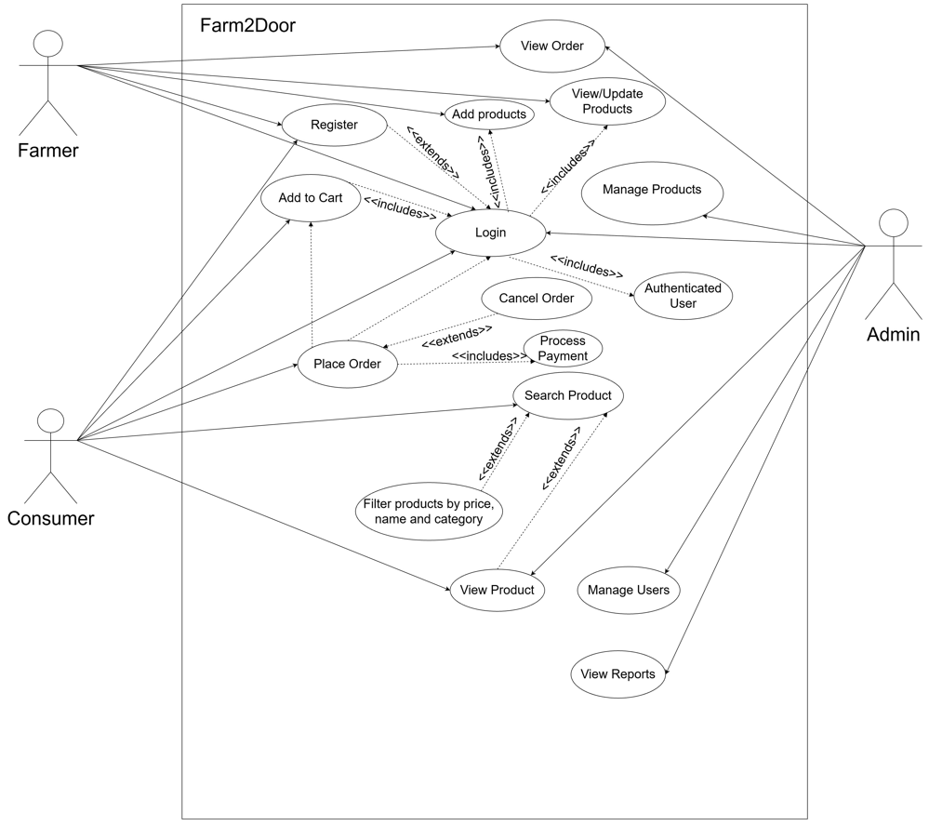
Figure 3.1: Use Case Diagram of Farm2Door
The Use Case Diagram for Farm2Door shows a number of features through which the main actors (Farmer, Consumer and Admin) use the system. At the centre of the diagram, Registration and Login processes have been set up as the main gateway to various activities depending on the actor’s role. The Consumer role after being properly authenticated is granted the opportunity to engage in various marketing activities starting from searching and filtering products to finally placing an order (Place Order use case) which also includes the payment part. The Farmers keep the market updated with their products either by adding new ones or refreshing the stock. Meanwhile, Admin’s functionalities encompass user management (thus ensuring the system integrity), checking and updating the product database and performing sales analysis through the consultation of the sales reports. This diagram is an excellent visual representation of the platform modular structure and user-oriented flow.
Table 3.1: Use Case for Registration Module
Field | Description
Use-Case ID | UC01 – Register
Primary Actor | Farmer / Consumer
Secondary  Actor | System
Description (Steps) | - User opens the registration page.  - User enters personal details (name, email, password, role, etc.).  - User submits the registration form.  - System validates the entered information (e.g., checks for unique email, password strength, required fields) and stores the info.
Success  Scenario | The user account is successfully created in the appropriate entity table  (Farmer or Consumer).
Failure  Scenario | Invalid or missing data is detected during validation, leading to registration denial. The System displays error messages next to the incorrect fields.

Table 3.2: Use Case for Login Module
Field | Description
Use-Case ID | UC02 – Login
Primary Actor | Authenticated User (Any Farmer, Consumer or Admin)
Secondary Actor | System
Description (Steps) | - User provides their login credentials to access the system.  - User submits the login form.  - System verifies the credentials against the stored records in the respective user tables.  - If credentials are correct, the System establishes a secure session.  - System grants access to the appropriate dashboard based on the user’s role.
Success Scenario | The user is successfully logged in, a session is started and the user is redirected to their dashboard.
Failure Scenario | Incorrect credentials are provided, leading to access denial. An error message is shown, indicating that the username or password entered does not match our records.

Table 3.3: Use Case for Add to Cart Module
Field | Description
Use-Case ID | UC-C04 – Add to Cart
Primary Actor | Consumer
Secondary Actor | System
Description (Steps) | - Consumer uses Search Product or View Product to find a desired product.  - Consumer clicks the “Add to Cart” button.  - If available, System updates the Consumer’s cart session with the product and quantity.
Success Scenario | The product is successfully added to the Consumer’s shopping cart session.
Failure Scenario | Quantity Error: The requested quantity is greater than the available Stock quantity. System displays an error message: “Quantity exceeds stock.”

Table 3.4: Use Case of Add Product Module
Field | Description
Use-Case ID | UC-F01- Add Product
Primary Actor | Farmer
Secondary Actor | System
Description (Steps) | - Farmer accesses the system (via Login) and navigates to the “Manage Products” section.  - Farmer clicks the “Add products” button.  - Farmer enters all required product details (name, category, price, stock quantity, threshold etc.).  - Farmer submits the form.  - System validates the input (e.g., price is positive, stock is numeric).  - System creates a new record in the Product table, associating it with the Farmer’s ID.
Success Scenario | The System successfully validates the input and creates a new, active product record in the Product table.
Failure Scenario | Validation Error: The Farmer enters invalid or missing data. The System rejects the submission and displays an error message, prompting the Farmer to correct the inputs.
Table 3.5: Use Case of Manage Users Module
Field | Description
Use-Case ID | UC-A01- Manage User
Primary Actor | Admin
Secondary Actor | System
Description (Steps) | - Admin accesses the system (via Login) and navigates to the “Manage Consumers or Manage Farmers section”.  - Admin searches or filters for a specific user (Farmer or Consumer).  - Admin selects a user and clicks “Block”  - Admin confirms changes.  - System validates the update and modifies the corresponding record in the Farmer or Consumer table.
Success Scenario | The System successfully validates and applies the modifications to the target user’s record in the database.
Failure Scenario | Database Error

Table 3.6: Use Case of View Reports
Field | Description
Use-Case ID | UC-A02- View Reports
Primary Actor | Admin
Secondary Actor | System
Description  (steps) | 1.Admin accesses the\ system (via Login) and navigates to “Reports”.  2. Admin selects a report type (e.g.Daily Sales, Inventory, Payments Report) and a date range.  3. System queries the relevant database tables (Order, Payment, Product, etc.).  4. System aggregates the data and displays the metrics in a summarized report format.
Success Scenario | The System successfully processes the complex query and displays the requested financial or operational report.
Failure Scenario | Query Error: A database connection error prevents the query from running. The System displays a generic error message and asks the admin to try again later.

3.1.1.2. Non-Functional Requirements
The non-functional requirements of the Farm2Door system define the quality standards the platform must maintain during operation. The system must provide reliable performance, fast response time and secure access to protect user data and transactions. It should support multiple users simultaneously without performance degradation while ensuring system stability and minimal downtime. The platform must also offer a user-friendly interface and maintain data accuracy to ensure smooth and efficient marketplace operations for farmers, consumers and administrators.
Some Non-Functional Requirements of Farm2Door are:
3.1.1.2.1. Performance Requirements
- Web pages (home, product listings, dashboards) should load within 3–5 seconds under normal conditions.
- The system should handle multiple farmers and consumers accessing the platform at the same time without performance issues.
- Search results and product listings should be displayed quickly (within 3 seconds).
3.1.1.2.2. Security Requirements
- All user accounts (farmers, consumers, admin) must be protected with username and password authentication.
- Access control must separate farmer, consumer and admin privileges.
- Sensitive data (user information, product details, orders) must be securely stored in the database.
- Only authorized roles can manage products, view orders or access reports.
3.1.1.2.3. Usability Requirements
- The interface must be simple and easy to navigate for all users (farmers, consumers, admin).
- Pages should be mobile-friendly and responsive.
- Farmers and consumers must clearly understand their actions (e.g. product added, order placed) through confirmation messages.
3.1.1.2.4. Reliability Requirements
- The system should be available with minimum downtime during normal operations.
- The system must guarantee that no data related to users, products or orders is lost during updates or transactions.
- Regular backups of the local database should be maintained.
3.1.1.2.5. Maintainability Requirements
- The system should be easy to upgrade (PHP code, database tables, UI components).
- Modules (login, product, management order handling, reporting) should be separated to make debugging and future enhancements easier.
3.1.1.2.6. Scalability Requirements
The system should handle future expansion with:
- More farmers and consumers.
- More product categories (beyond vegetables, if required later).
3.1.1.2.7. Compatibility Requirements
- The system should run across all major browsers (Chrome, Edge, Firefox, Safari).

3.1.2. Feasibility Analysis
3.1.2.1. Technical Feasibility
The project is technically feasible because it uses mature, well-supported technologies.
The system is built with HTML, CSS, JavaScript, PHP and MySQL, all of which are lightweight and available on any standard web server or XAMPP.
Hardware requirements are minimal (standard PCs/laptops with 4GB RAM and internet access) and no specialized tools are required.
Thus, the system can be successfully developed and deployed using the existing technical resources.
3.1.2.2. Operational Feasibility
Acceptance of the system from farmers, consumers and admins would be easy because it simplifies tasks and reduces errors compared to manual processes. The interfaces are simple, intuitive and require only basic computer knowledge.
Farmers can register and manage products with little training, Consumers can browse and place orders instantly and admin can manage users and products with minimal effort.
Thus, the operational feasibility of the system promotes smooth functioning in day-to-day academic activities.
3.1.2.3. Economic Feasibility
Manual errors, paperwork and hidden administrative time are reduced by this solution, making it economically feasible. The technologies used (PHP, MySQL, XAMPP) are open-source and free, requiring no licensing costs. The benefits of fair pricing for farmers and affordable products for consumers far exceed the slight costs of development and deployment. Therefore, the project is economically feasible.
3.1.2.4. Schedule Feasibility
The scheduling in this project is achievable since:
- Requirements, use cases, diagrams and SRS structure are already well-defined.
- Project modules (login, product management, order placement, reporting and user management) are relatively easy to implement in phases.
- Rapid development is supported by the chosen technologies (PHP, MySQL).
- The defined scope and phased approach ensure that the system can be developed, tested and delivered within the allotted semester timeframe.
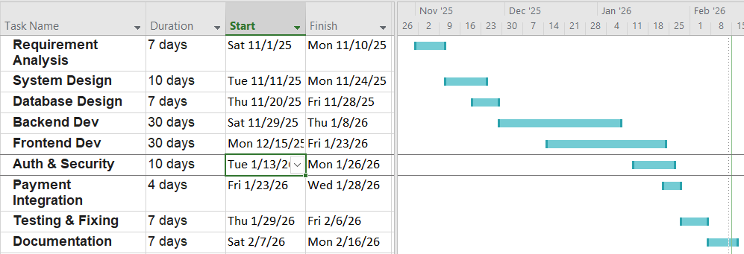
Figure 3.2: Gantt Chart of Farm2Door
This Gantt chart outlines the development timeline of the Farm2Door project, showing each phase and its duration. The project begins with Requirement Analysis to understand system needs, followed by System and Database Design to plan the structure. Backend Development and Frontend Development run next, building the core functionality and user interface. Authentication and Security ensures safe user access, while Payment Integration enables secure transactions. Testing and fixing verifies system reliability and removes errors. Finally, Documentation completes the project by recording system details and usage. The schedule demonstrates a structured workflow, overlapping tasks for efficiency and a clear progression from planning to deployment.

3.1.3. Data Modelling (ER-Diagram)
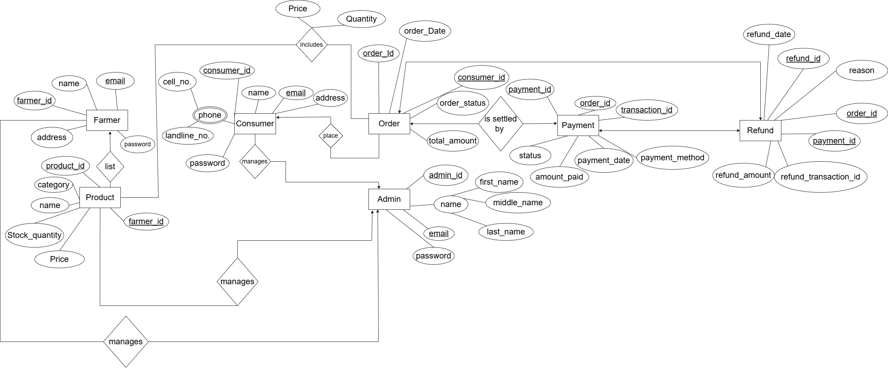
Figure 3.3: ER Diagram of Farm2Door
The Entity-Relationship (ER) Diagram of Farm2Door system basically describes the main frame of the platform’s data and rules for business usage. Besides that, it lists the main entities (Farmer, Consumer, Admin and Product) with some of their attributes (IDs, names and contacts). Two main relationships are summarized by short phrases: Farmers list Products and Consumers place Orders. The ER diagram also depicts how an order can include multiple products and a payment can be made for an order to explain complex order scenarios. It further shows a Refund entity which is associated with the original orders and payments to describe the refund process. This schema not only makes it easier to logically organize all data interactions from inventory control to financial settlements, but also be able to maintain a high level of system integrity.

3.1.4. Process Modelling (Logical DFD)
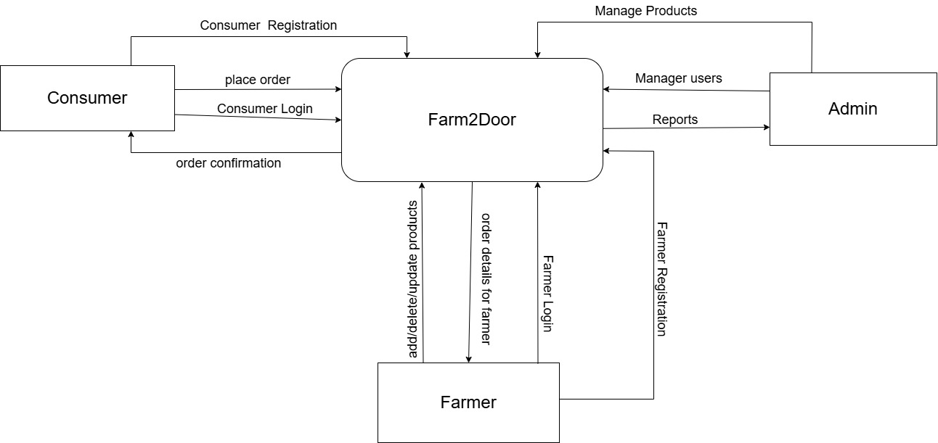
Figure 3.4: DFD Level 0 of Farm2Door
The Level 0 Data Flow Diagram (DFD), also known as the Context Diagram provides a high-level overview of the Farm2Door system’s boundaries and its interactions with external entities. The diagram identifies three primary actors: Consumer, Farmer and Admin. Consumers interact with the system through registration and login processes to place orders and receive confirmations. Farmers provide product data and receive order details, while the admin manages the overall user base and generates operational reports. By centralizing these information flows, the diagram illustrates how the system acts as a digital intermediary, facilitating the seamless exchange of data between agricultural producers and end-users.

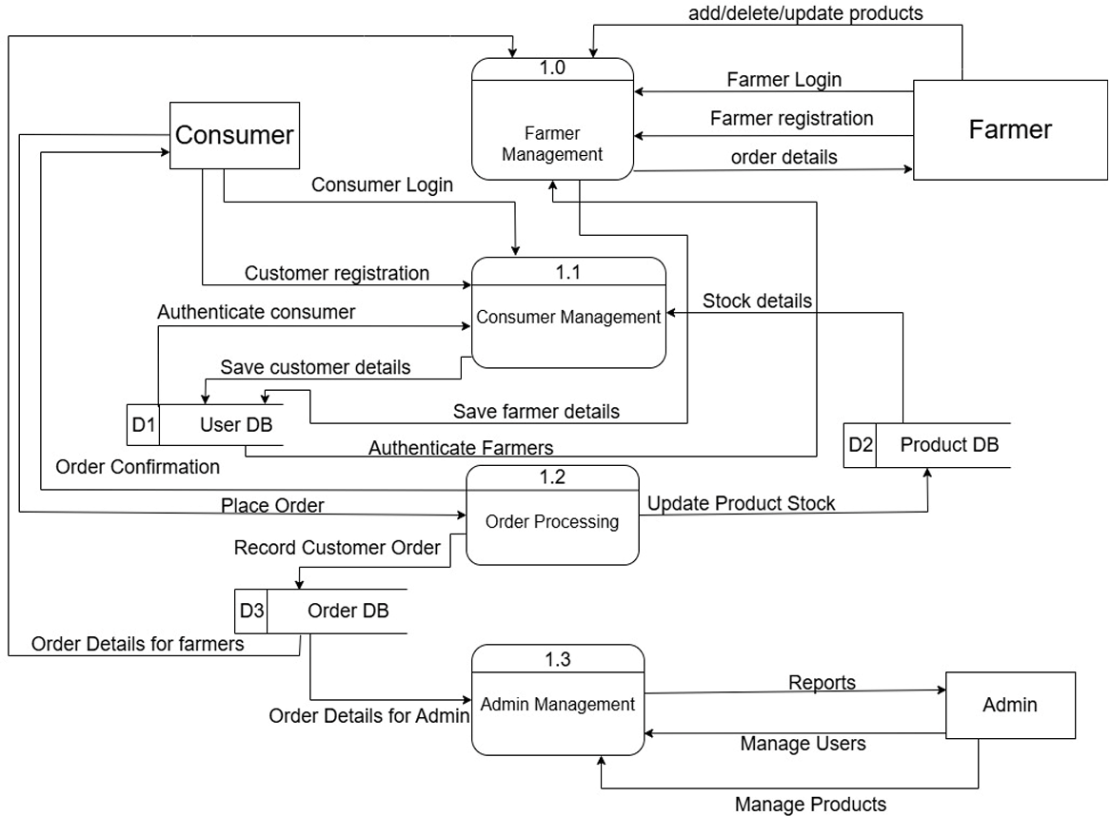
Figure 3.5: DFD Level 1 of Farm2Door
The Level 1 Data Flow Diagram (DFD) for Farm2Door decomposes the context-level process into four core functional modules: Farmer Management (1.0), Consumer Management (1.1), Order Processing (1.2) and Admin Management (1.3). This diagram illustrates how data travels between actors and specific data stores. User data is routed through management modules to the User DB (D1) for authentication and registration. The Order Processing module coordinates between consumers and farmers, simultaneously updating Product Stock (D2) and recording transactions in the Order DB (D3). Finally, the Admin Management module aggregates data from these stores to facilitate user oversight and generate operational reports, providing a detailed blueprint of the system’s internal logic.

3.2. System Design
System design for Farm2Door was carried out to define the overall architecture, components, modules, data structures and interfaces required to meet the system’s requirements. It transforms functional needs such as product listing, ordering, payment and delivery tracking and non-functional needs like security, performance and scalability into a clear implementation blueprint. The design organizes modules including user management, inventory control, order processing and payment integration to work together efficiently.

3.2.1. Architectural Design
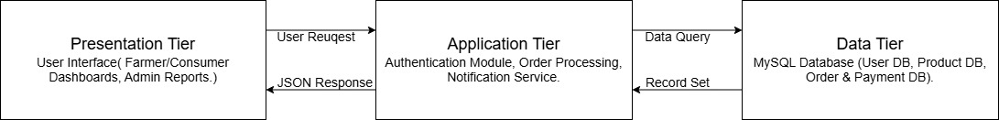
Figure 3.6: Three-tier Architecture of Farm2Door
The architecture design of Farm2Door is based on three tier architecture. It allows the Farm2Door system to support separation of concerns, ease of maintainability and better scalability.
3.2.1.1. Presentation Tier
The Presentation Layer serves as the primary interface through which users interact with the Farm2Door ecosystem. This layer uses HTML, CSS and JavaScript to display all visual components which include the Farmer Dashboard and the Consumer Shopping Portal and the Admin Dashboard. The system handles user interactions because it captures user input through active elements, which it sends to the server using secure HTTPS protocols. The product listing system and order view system of the layer were built to deliver digital product information to farmers who have different levels of online skills, by making the system simple and the product information easy to understand on all devices.
3.2.1.2. Application Tier
The Application Layer operates as the primary control unit for the system which processes data through PHP code on an Apache web server. The system functions as a mediator which processes user interface requests after confirming user identity to permit authorized system operations. The system permits registered farmers to create product listings while only authorized consumers are allowed to submit purchase orders. The layer handles user verification by implementing particular rules which enable it to perform real-time stock updates, order status processing automated notification email. This layer establishes a secure area between the frontend and database which prevents public access to MySQL raw data while maintaining all system operational rules.

3.2.1.3. Data Tier
The Data Layer serves as the system base which uses MySQL Relational Database Management System (RDBMS) to achieve data consistency. The tier uses organized table structures to keep essential data which includes farmer details and product information and consumer account information and order information. The system functions as a storage bin because it enforces data integrity through relational constraints which prevent the sale of out-of-stock products and automatic order payment verification. The Data Layer manages system statistics and financial reports which function as the facility that enables Admin Dashboard users to create precise growth and profit statistics.

3.2.2. Database Schema Design
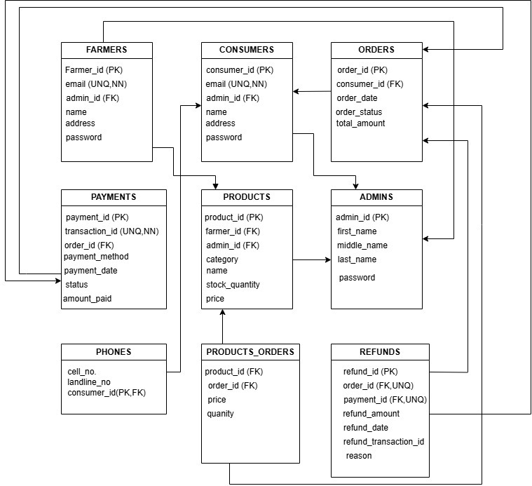
Figure 3.7: Relational Diagram of Farm2Door
The Relational Diagram for the Farm2Door system shows a database design that uses multiple tables to control access in agricultural marketplaces. The schema establishes three main user groups which include Farmers, Consumers and Admins to create a foundation for secure transaction processing. Farmers use foreign keys from the Products table to connect with inventory management systems for accurate tracking of their inventory. The Orders and Payments tables handle sales operations by tracking both purchase times and payment. The Products_Orders table manages the relationship between items and sales while the Refunds table establishes rules for handling returned items which creates a secure system for data protection.
Table 3.7: Data Dictionary of Customer
Field Name | Datatype | Constraint
customer_id | int(11) | Primary key, AUTO_INCREMENT
firstName | varchar(100) | NOT NULL
lastName | varchar(100) | NOT NULL
Email | varchar(100) | Unique Key, NOT NULL
Password | varchar(255) | NOT NULL
Phone | varchar(15) | NULL
Address | varchar(255) | NULL
Terms | tinyint(1) | NOT NULL
created_at | datetime | DEFAULT current_timestamp()
status | enum(‘active’, ‘blocked’) | DEFAULT ‘active’
reset_token | varchar(255) | NULL
reset_expires | datetime | NULL

Table 3.8: Data Dictionary of Farmer
Field Name | Datatype | Constraint
farmer_id | int(11) | Primary key, AUTO_INCREMENT
firstName | varchar(100) | NOT NULL
lastName | varchar(100) | NOT NULL
Email | varchar(100) | Unique Key, NOT NULL
Password | varchar(255) | NOT NULL
Phone | varchar(15) | NULL
Address | varchar(255) | NULL
Terms | tinyint(1) | NOT NULL
created_at | datetime | DEFAULT current_timestamp()
status | enum(‘active’, ‘blocked’) | DEFAULT ‘active’
reset_token | varchar(255) | NULL
reset_expires | datetime | NULL

Table 3.9: Data Dictionary of Order
Field Name | Datatype | Constraint
order_id | int(11) | Primary key, AUTO_INCREMENT
customer_id | int(11) | Foreign Key, NOT NULL
total_amount | decimal(10,2) | NOT NULL
order_status | enum(‘Pending’, ‘Processing’, ‘Dispatched’, ‘Received’, ‘Ready to pickup’, ‘Cancelled’, ‘Rejected’) | DEFAULT ‘Pending’
order_date | timestamp | NOT NULL, DEFAULT current_timestamp()
shipping_name | varchar(100) | NULL
shipping_phone | varchar(20) | NULL
shipping_address | text | NULL
shipping_notes | text | NULL
rejection_reason | text | NULL
cancellation_reason | text | NULL

Table 3.10: Data Dictionary of Order_items
Field Name | Datatype | Constraint
item_id | int(11) | Primary key, AUTO_INCREMENT
order_id | int(11) | Foreign Key, NOT NULL
product_id | int(11) | Foreign Key, NOT NULL
farmer_id | int(11) | Foreign Key, NOT NULL
quantity | int(11) | NOT NULL
price_per_unit | decimal(10,2) | NOT NULL
subtotal | decimal(10,2) | NOT NULL
Table 3.11: Data Dictionary of Payments
Field Name | Datatype | Constraint
payment_id | int(11) | Primary key, AUTO_INCREMENT
order_id | int(11) | Foreign Key, NOT NULL
payment_method | varchar(50) | NOT NULL, DEFAULT ‘COD’
payment_status | enum(‘Pending’, ‘Paid’, ‘Refunded’) | DEFAULT ‘Pending’
transaction_id | varchar(100) | NULL
amount_paid | decimal(10,2) | NOT NULL
payment_date | timestamp | NOT NULL, DEFAULT current_timestamp()

Table 3.12: Data Dictionary of Product
Field Name | Datatype | Constraint
product_id | int(11) | Primary key, AUTO_INCREMENT
farmer_id | int(11) | Foreign Key, NOT NULL
name | varchar(100) | NOT NULL
category | varchar(50) | NOT NULL
price | decimal(10,2) | NOT NULL
stock_quantity | int(11) | NOT NULL
threshold | int(11) | NULL, DEFAULT 5
description | text | NULL
image | varchar(255) | NOT NULL
created_at | timestamp | NOT NULL, DEFAULT current_timestamp()

Table 3.13: Data Dictionary of Cart
Field Name | Datatype | Constraint
cart_id | int(11) | Primary key, AUTO_INCREMENT
customer_id | int(11) | Foreign Key, NOT NULL
product_id | int(11) | Foreign Key, NOT NULL
quantity | int(11) | NOT NULL, DEFAULT 1
created_at | timestamp | NOT NULL, DEFAULT current_timestamp()

Table 3.14: Data Dictionary of Refund
Field Name | Datatype | Constraint
refund_id | int(11) | Primary key, AUTO_INCREMENT
order_id | int(11) | Foreign Key, NOT NULL
payment_id | int(11) | Foreign Key, NOT NULL
refund_transaction_id | varchar(100) | Unique Key, NOT NULL
refund_amount | decimal(10,2) | NOT NULL
reason | varchar(255) | NOT NULL
refund_date | timestamp | NOT NULL, DEFAULT current_timestamp()

Table 3.15: Data Dictionary of Contact us
Field Name | Datatype | Constraint
id | int(11) | Primary key, AUTO_INCREMENT
Name | varchar(50) | NOT NULL
Email | varchar(50) | NOT NULL
Message | varchar(255) | NOT NULL

3.2.3. Interface Design
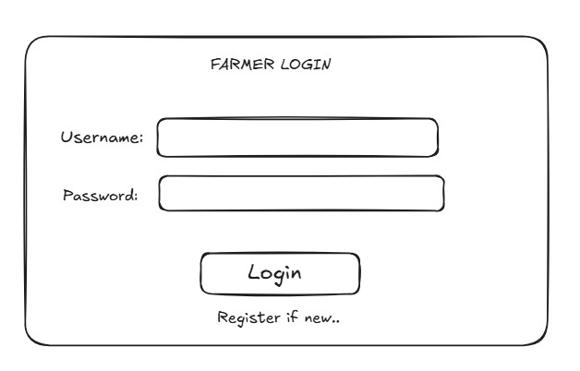
Figure 3.8: UI Design of Farmer Login
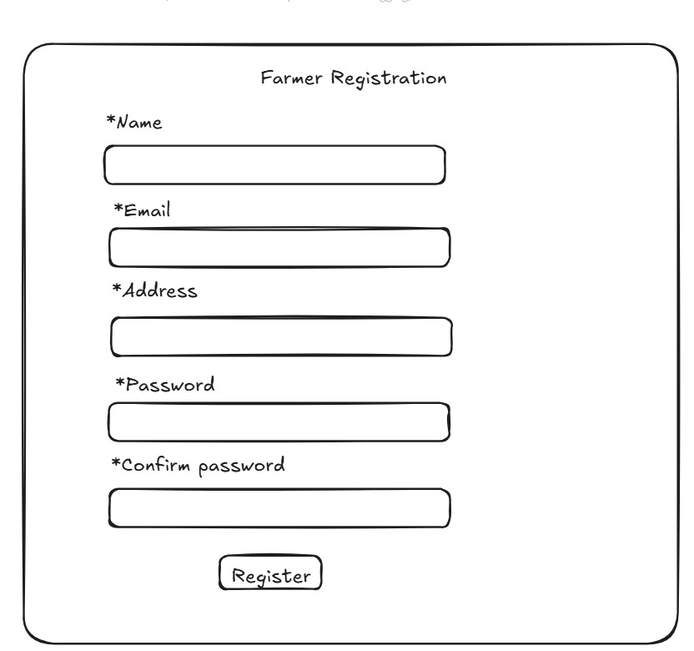
Figure 3.9: UI Design of Farmer Registration
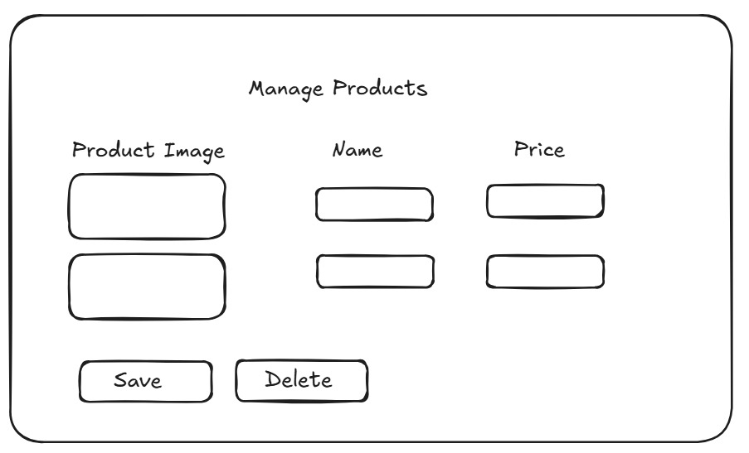
Figure 3.10: UI Design for Manage Products
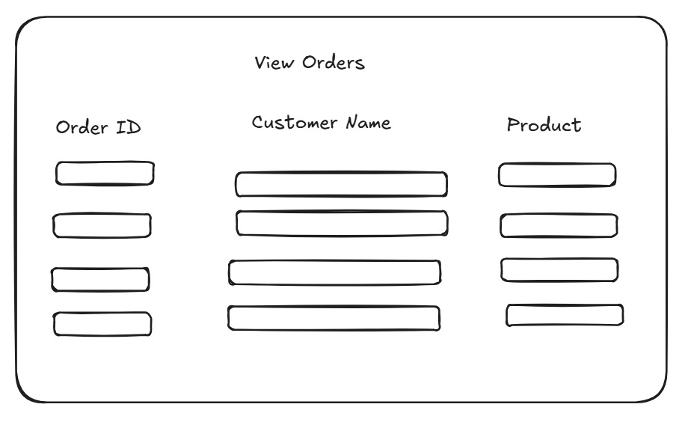
Figure 3.11: UI Design of View Orders

3.2.4. Physical DFD
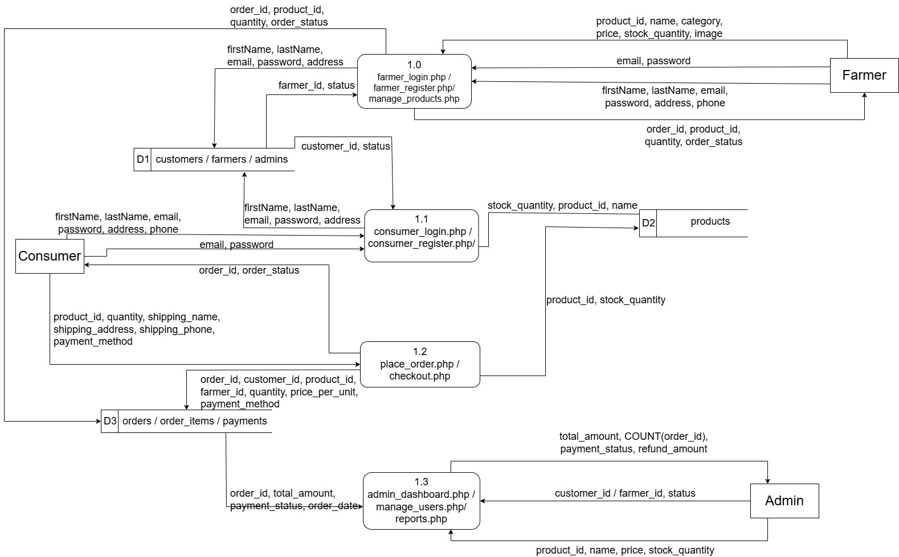
Figure 3.12: Physical DFD of Farm2DOor
The Physical Data Flow Diagram of Farm2Door illustrates the actual implementation of the system using PHP files and database tables. The diagram consists of four processes:farmer_login.php/farmer_register.php/manage_products.php(1.0),consumer_login.php/consumer_register.php (1.1), place_order.php/checkout.php (1.2) and admin_dashboard.php/manage_users.php/reports.php (1.3). Three data stores are used: D1 (consumers/farmers/admins), D2 (products) and D3 (orders/order_items/payments). Farmers submit credentials and product details such as product_id, name, category, price and stock_quantity to process 1.0. Consumers register and login through 1.1, then place orders via 1.2 passing product_id, quantity, shipping details and payment_method. Order records including order_id, customer_id, farmer_id, quantity and price_per_unit are stored in D3. The admin retrieves total_amount, COUNT(order_id), payment_status and refund_amount through reports.php for monitoring and decision-making.

Implementation and Testing

4.1. Implementation
In this stage, design specifications are translated into an operational and stable software solution. This is where the system is developed. On receiving the system design documents, the work is divided in modules and actual coding is started. It is followed by testing. Several tools are used in this phase of the software development.

4.1.1. Tools Used
The following tools and technologies were used for the implementation of the system:
- CASE Tools: Figma (Used for designing user interface prototypes and wireframes, ensuring a clean and intuitive layout), Draw.io (Utilized for creating DFDs, Entity-Relationship Diagrams (ERDs) and UML diagrams to represent system design), VS Code (Used for coding), Git and Github (for tracking changes in code and backup of project).
- Programming Languages: HTML, CSS, JavaScript (Frontend), PHP (Backend), HighCharts (for visualizing data).
- Database Platform: MYSQL (Used to store and manage user data, product details and order information).

4.1.2. Implementation Details of Modules
4.1.2.1. Authentication Module
This module is intended for user login and role-based access. Credentials are validated against the user database and the system routes the user to the appropriate interface according to the roles: Farmer, Consumer or Admin.
Algorithm:
Step 1: Start
Step 2: Open login interface.
Step 3: User enters username and password.
Step 4: Validate credentials with user database.
Step 5: If credentials are valid create session and store user role.
Step 6: Redirect user to role-based dashboard (Farmer /Consumer / Admin).
Step 7: If invalid display error and request re-login.
Step 8: Terminate session on logout, browser close, or session timeout.
Step 9: End
4.1.2.2. Product Management (Farmer)
The Product Management module allows farmers to add, update and delete product details such as name, price, quantity and description.
Algorithm:
Step 1: Start.
Step 2: Authenticate Farmer and load the Farmer Dashboard.
Step 3: Input product details (Name, Category, Price, Stock Quantity).
Step 4: Execute the database command to Add, Update, or Delete records in the Product DB.
Step 5: Synchronize changes with the display list to reflect real-time inventory.
Step 7: End

4.1.2.3. Order Management (Farmer)
The Order Management module enables Farmer to manage the incoming orders from consumers. It involves accepting or rejecting orders and dispatching order to the Farm2Door Collection hub.
Algorithm
Step 1: Start
Step 2: Farmer logs into the dashboard.
Step 3: Open the Order section.
Step 4: System retrieves pending orders from the database.
Step 5: Display order details including product name, quantity, price and consumer information.
Step 6: Farmer selects an order for review.
Step 7: Farmer chooses to accept or reject the order.
Step 8: If the order is accepted, update the order status to processing.
Step 9: Send acceptance notification to the consumer.
Step 10: After farmer dispatches the order to Farm2Door Collection Hub
Step 11: Update order status to dispatched.
Step 12: If the order is rejected, update the order status to rejected.
Step 13: End

4.1.2.4. User Management (Admin)
The User Management module allows the admin to manage farmer and consumer accounts. It allows admin to block consumer and farmers which prevents them to access the login feature. All the products of blocked farmers are invisible to consumers.
Algorithm:
Step 1: Start
Step 2: Admin logs into the admin dashboard.
Step 3: Open the User Management section.
Step 4: System displays the list of registered farmers and consumers.
Step 5: Admin selects a user account.
Step 6: Admin chooses to block or unblock account.
Step 7: If blocking a user, change account status to blocked.
Step 8: Prevent blocked users from accessing the login system.
Step 9: If the blocked user is a farmer, hide all their products from consumer listings.
Step 10: End
4.1.2.5. Reports (Admin)
The Analytics and Reporting module processes order and product data for analysis and visualization. Reports such as daily Sales, product stock levels, payments report are generated automatically after putting start and end date and displayed on the admin dashboard with the help of highcharts.
Algorithm:
Step 1: Start
Step 2: Admin logs into the admin dashboard.
Step 3: Open the Analytics and Reporting section.
Step 4: Enter the start date and end date for the report.
Step 5: Submit the request for report generation.
Step 6: System retrieves order, product and payment data from the database within the selected date range.
Step 7: Process the retrieved data to calculate totals and summaries.
Step 8: Generate reports including daily sales, product stock levels and payment summaries.
Step 9: Convert processed data into charts and tabular formats for visualization.
Step 10: Display the generated reports on the admin dashboard.
Step 11: Allow admin to refresh or change date range to regenerate reports.
Step 12: End

4.2. Testing
The testing process shows that the Farm2Door platform functions properly while it meets all of its established performance standards and operational requirements. The team conducts assessment of all system modules which include Authentication and Product Management and Order Processing to evaluate their accuracy and reliability and usability.

4.2.1. Test Cases for Unit Testing
Unit testing process evaluates each software component of the Farm2Door system through tests on its individual classes and methods to confirm proper functioning in isolated tests. The testing process evaluates systems main components Authentication, Product Management, Order Processing and Report Generation through separate tests which verify their ability to process inputs and interact with the database according to designed specifications. Steps followed in performing unit tests:
- Conduct the code execution test
- Identify and resolve any errors
- Determine that the test is complete
4.2.1.1. Authentication Module
Pre-conditions: User should be Registered
Table 4.1: Test Case for Login Module
Test Case ID | Test Description | Test Steps | Input Data | Expected  Result | Actual Result | Status
TC_F2D_01 | Valid Consumer Login | 1. Open Login Page.  2. Enter valid credentials  3. Click Login | Username: sherpajack3@gmail.com,  Password: Tashi@001 | Should be redirected to Home page | Consumer  redirected to Home page  successfully | Pass
TC_F2D_02 | Invalid Consumer Login | 1. Open Login Page.  2. Enter wrong credentials  3. Click Login | Username: consumer1,  Password: wrongpass | Should display  Error message as “Invalid Email or Password” displayed | Showed “Invalid Email or Password” | Pass
TC_F2D_03 | Valid Farmer Login | 1. Open Login Page.  2. Enter valid farmer credentials  3. Click Login | Username: mahtoneha2555@gmail.com,  Password: farm123 | Should be redirected to farmer dashboard | Farmer redirected to farmer Dashboard | Pass
TC_F2D_04 | Invalid Farmer Login | 1. Open Login Page.  2. Enter wrong farmer credentials  3. Click Login | Username: farmer1,  Password: wrongpass | Should show error message “Invalid Email or Password” displayed | Showed “Invalid Email or Password” | Pass
TC_F2D_05 | Valid Admin Login | 1. Open Login Page.  2. Enter valid admin credentials.  3. Click Login | Username: mahtoneha255@gmail.com,  Password: Neha@001 | Should be redirected to admin dashboard | Admin  redirected to admin dashboard | Pass
4.2.1.2. Product Management Module:
Pre-conditions: User Should be logged in
Table 4.2: Test Case for Product Management Module
Test Case ID | Test Description | Test Steps | Input Data | Expected  Result | Actual Result | Status
TC_F2D_PM_01 | Add Product with Valid Data | 1.Open Add Product section.  2. Enter valid details.  3. Click add product. | Product Name: Tomato  Price: 80  Quantity: 50 kg  Description: Fresh Tomatoes  Image: Tomatoes image | Product should be added successfully | Product added successfully | Pass
TC_F2D_PM_02 | Add Product with Missing Name | 1.Open Add Product section.  2.Leave product name Empty.  3. Click add product. | Product Name:  Price: 80  Quantity: 50 kg  Description: Fresh Tomatoes  Image: Tomatoes image | Should display Product name is required | Displayed Product name is required | Pass
TC_F2D_PM_03 | Add Product with Invalid Price | 1.Open Add Product section.  2.Enter Negative Price.  3. Click add product. | Product Name: Tomato  Price: -80  Quantity: 50 kg  Description: Fresh Tomatoes  Image: Tomatoes image | Should display valid price is required | Displayed valid price required | Pass
TC_F2D_PM_04 | View Product List | 1. Open View/Update Products section | Not required | Should  display  Product list | Product list displayed | Pass
TC_F2D_PM_05 | Update Product Details | 1. Open View/Update Products section  2. Select product.  3. Edit details.  4. Click Update. | Price: 90 | Should display Product updated successfully | Displayed Product updated successfully | Pass
TC_F2D_PM_06 | Delete Product | 1. Open View/Update products section.  2. Select product.  3. Click Delete. | Not required | Should display Product deleted successfully | Displayed Product deleted successfully | Pass

4.2.1.3. Report Generation Module:
Pre conditions: Admin is logged in
Table 4.3: Test Case for Report Generation Module
Test Case ID | Test Description | Test Steps | Input Data | Expected  Result | Actual Result | Status
TC_F2D_DS_01 | Generate Daily  Sales Report | 1. Open Reports section.  2. Select Daily Sales report.  3. Input the start and end date  4. Click Generate | Start date: 2025/12/1  End date:  2026/2/1 | Total daily sales within the specified date should be displayed | Displayed total daily sales within the specified date | Pass
TC_F2D_PR_02 | Generate  Payments Report | 1. Open Reports section.  2. Select Payments Report.  3. Input the start and end date  4. Click Generate | Start date: 2025/12/1  End date:  2026/1/1 | Should displayed total Paymets received, Total Refunds  And net payments received | Successfully Displayed  total paymets received, Total Refunds  And net payments received | Pass

4.2.2. Test Case for System Testing
The system testing process assesses the full system functionality together with the complete system integration of all system components to confirm they function as a single system. The Farm2Door system undergoes complete system testing to confirm its compliance with all functional requirements which include end-to-end order processing from Farmer to Consumer and all non-functional requirements which include security measures and system performance standards.
Table 4.4: Test Case for System Testing of Farm2Door
Test Case ID | Test Description | Test Steps | Input Data | Expected  Result | Actual Result | Status
TC_F2D_SYS_01 | Farmer Product Management | 1. Login as Farmer.  2. Navigate to ‘Add Product’.  3. Fill details and submit. | Valid Farmer Credentials  Item: "Fresh Tomato"  Stock: 50kg  Price: Rs. 60 | Product should be saved in database and should appear on the products page. | Product successfully added and visible in products section | Pass
TC_F2D_SYS_02 | Consumer buys product | 1. Login as Consumer.  2. Add "Tomato" to cart.  3. Proceed to Checkout. | Consumer Credentials:  Email : sherpajack3@gmail.com  Password:  Tashi@001 | Order should be placed successfully, inventory should be updated successfully ,  sales report updated successfully | Order placed successfully,  Inventory Updated successfully, Sales report updated successfully | Pass
TC_F2D_SYS_03 | Sales report update after order | 1. Complete an order.  2. Login as Admin.  3. Open ‘Sales Report’. | Admin Credentials:  Email: mahtoneha255@gmail.com  Password:  Neha@001 | The Admin  dashboard should include the new order in the total sales and revenue calculation. | Sales report accurately included the recent order. | Pass
TC_F2D_SYS_04 | Farmer Stock Update and display order details | 1. Farmer logs in.  2. Views ‘My Products’.  3. Checks ‘Stock’ column.  4. View Orders | Farmer Credentials:  Email: mahtoneha2555@gmail.com  Password: Neha@001 | Stock should update after each sale and placed orders should appear in the received section. | Stock count was updated correctly in the farmer panel and received section in orders shows order data. | Pass

Conclusion and Future Recommendations

5.1. Lesson learnt/Outcome
The journey of developing the Farm2Door application has been a significant learning experience that strengthened our understanding of building a practical digital marketplace. We discovered how crucial it is to design systems with role-based access, ensuring that farmers, consumers and administrators interact with the platform according to their responsibilities. We also realized the importance of creating intuitive user interfaces that simplify tasks such as product listing, browsing and order placement.
Another key outcome was gaining hands-on experience with system modeling tools like DFDs and ER diagrams, which helped us visualize workflows and relationships clearly.
Overall, the project not only enhanced our technical skills but also gave us insight into how technology can empower farmers, streamline consumer purchasing and support fair trade practices in agriculture.

5.2. Conclusion
This system has been effective in addressing the challenges of traditional agricultural trading by providing a faster, more accurate and organized way for farmers and consumers to interact. Products are readily available for consumers to browse and purchase, while farmers can easily manage their listings and track orders. At the same time, the system and its users can be efficiently monitored and managed by the admin. Hence, the platform not only makes processes transparent and less error-prone but also promotes fair pricing, improves accessibility and supports better decision-making in the management of agricultural trade.

5.3. Future Recommendations
The proposed future enhancements for the Farm2Door system include:
- Mobile access applications to allow farmers and consumers to manage products and place orders conveniently from anywhere.
- Automated notifications to farmers and consumers regarding order updates, product availability and system alerts.
- Multilingual support to make the platform more accessible to local farmers and consumers in their native languages.
- Advanced reporting tools for admins to analyze sales trends, monitor performance and support better decision-making.

Appendices
i. Home Page
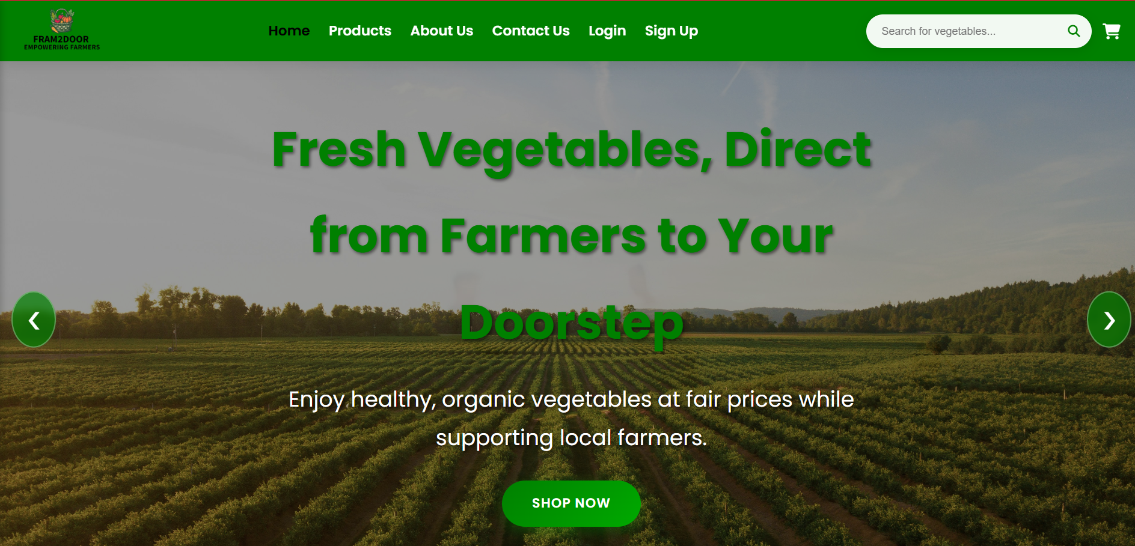
ii. Farmer Login Page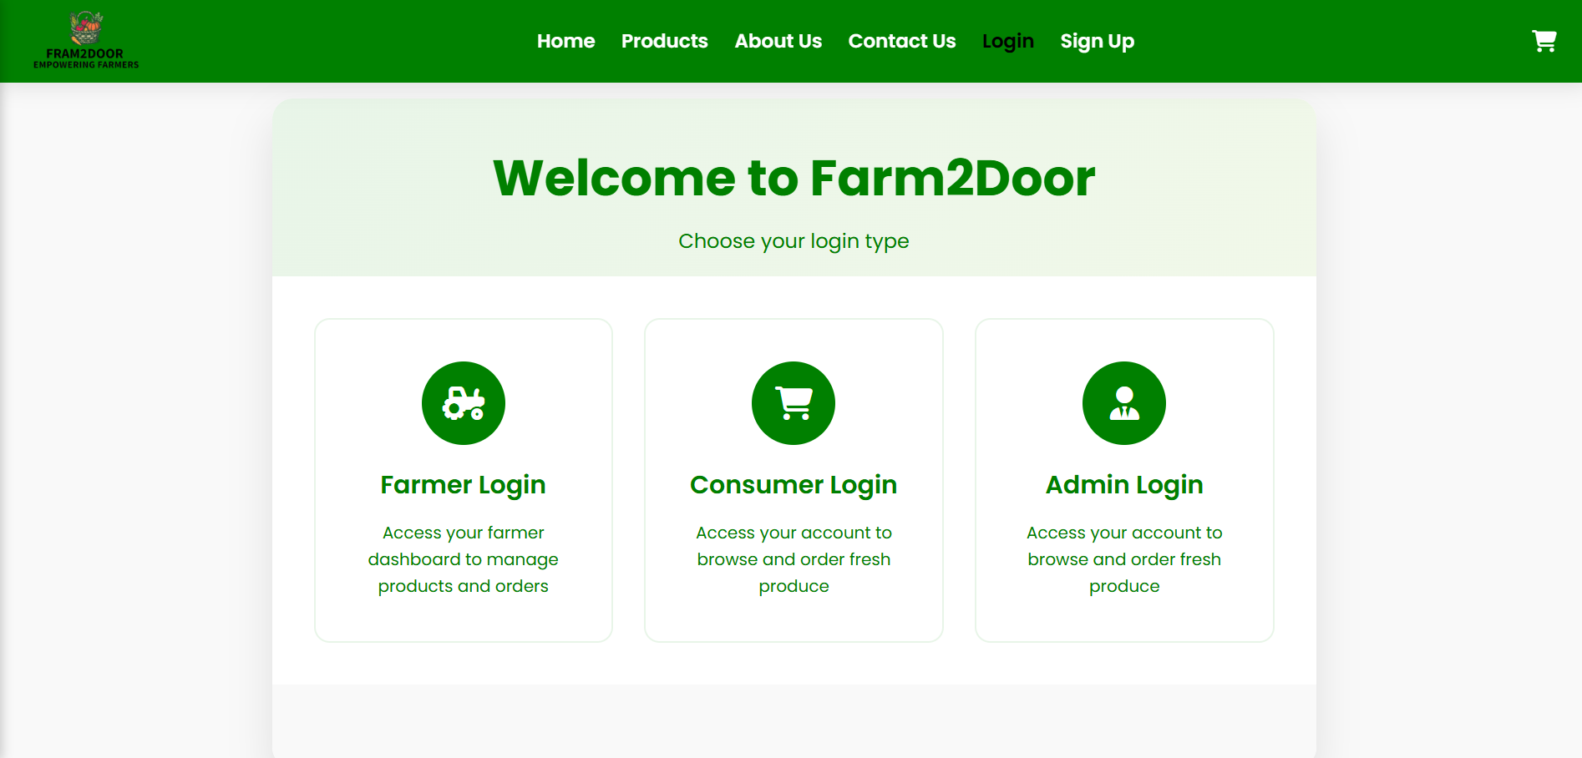
iii. Products Page
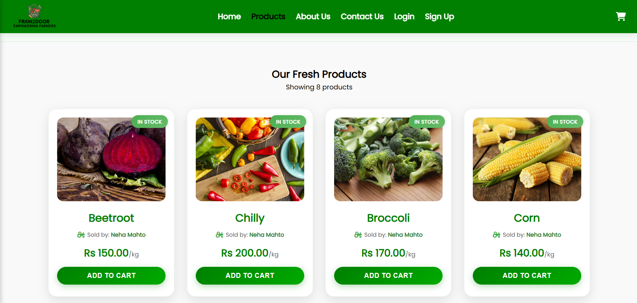
iv. Farmer Dashboard
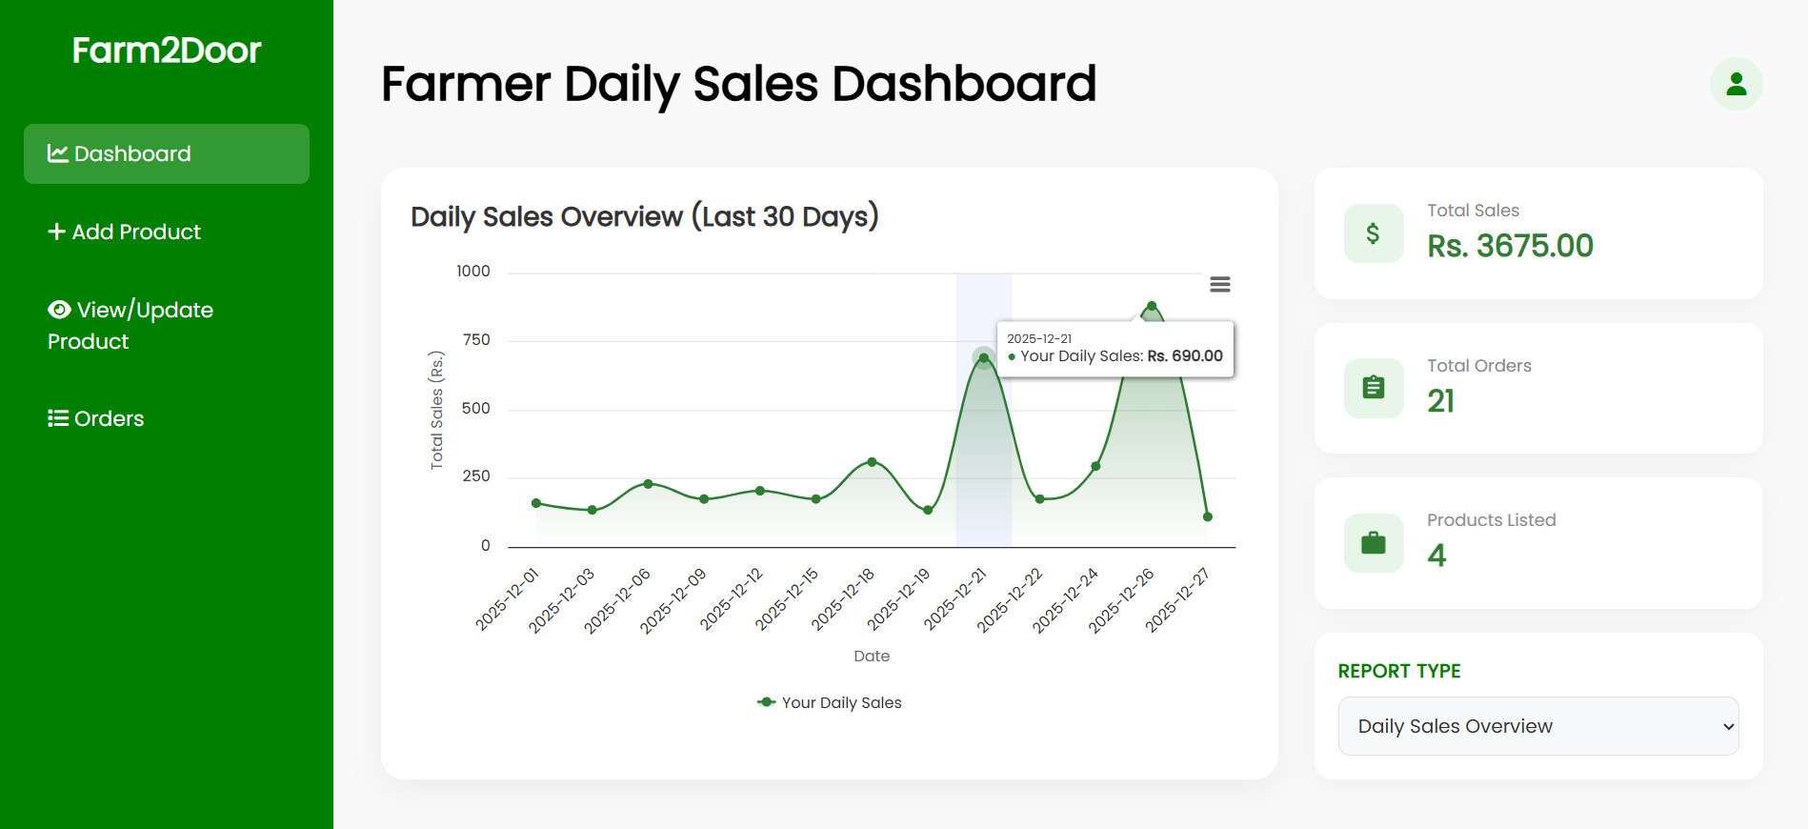
v. Admin Reports Section
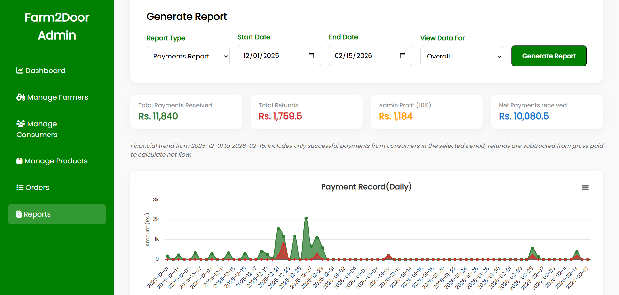
vi. Source Code
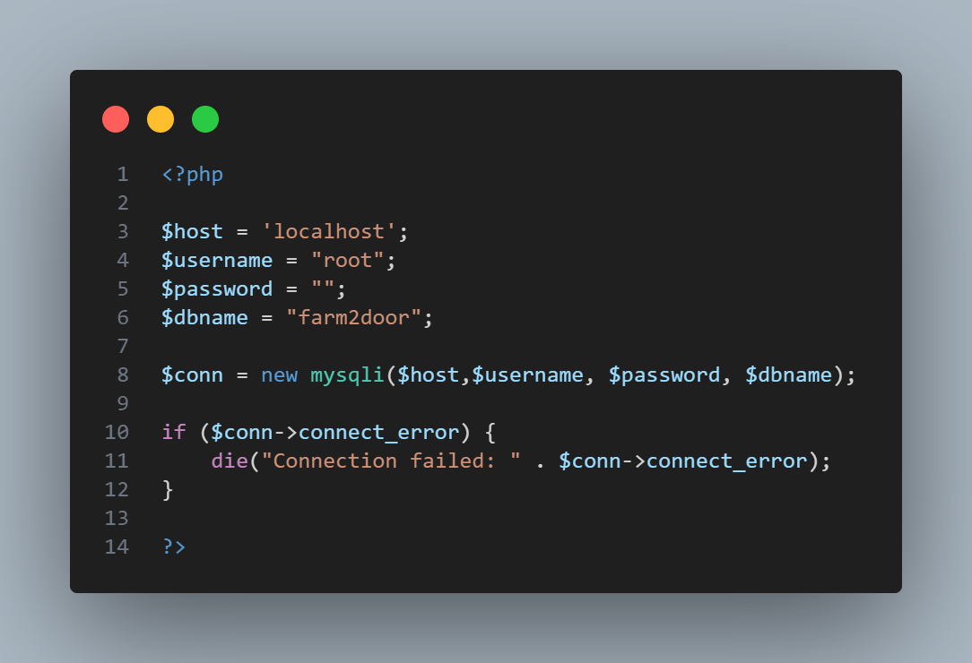

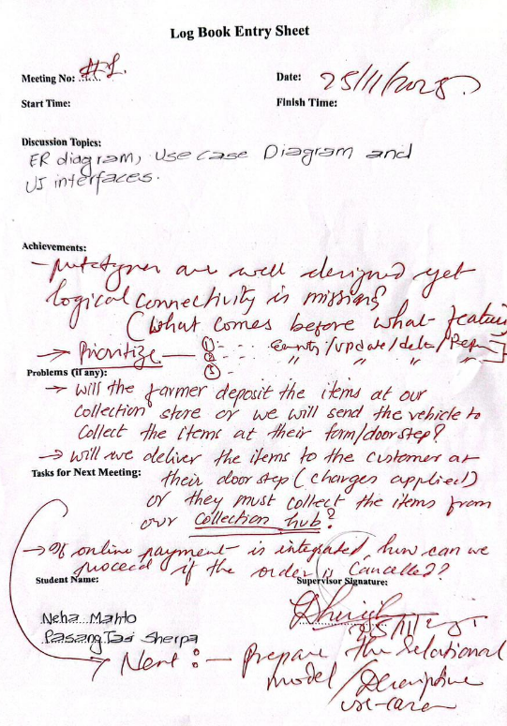

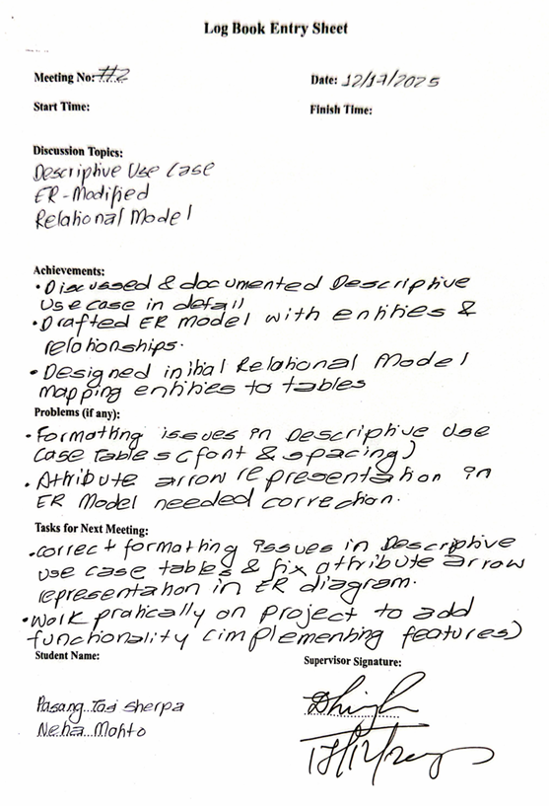
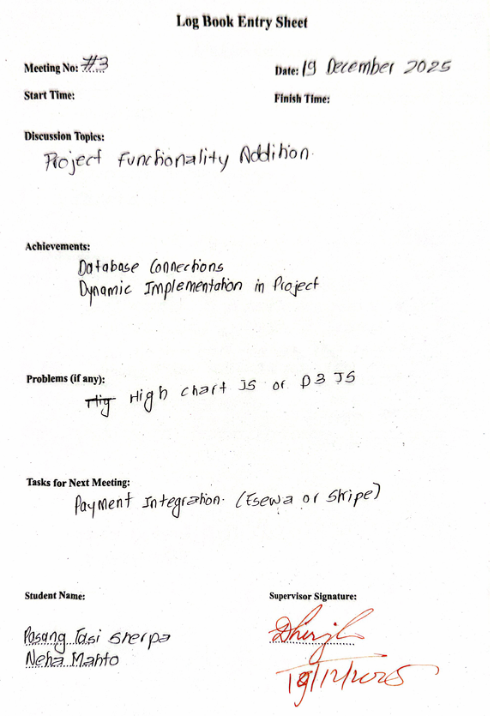

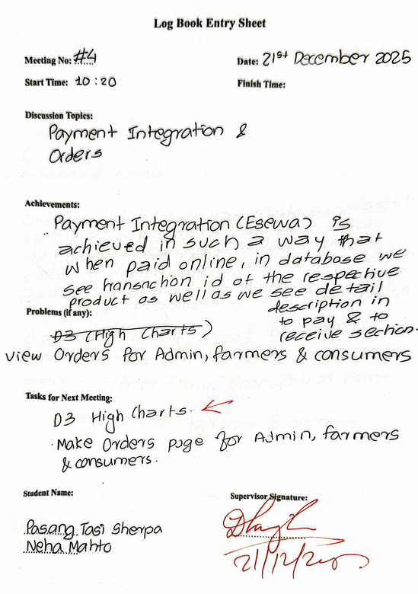

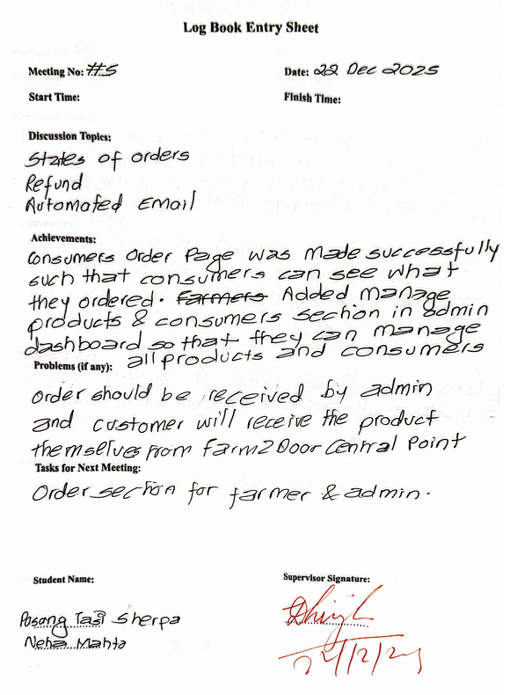

s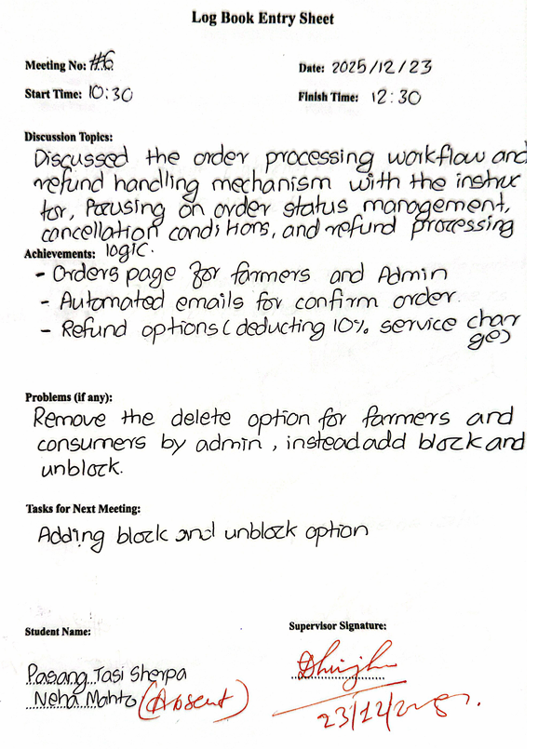

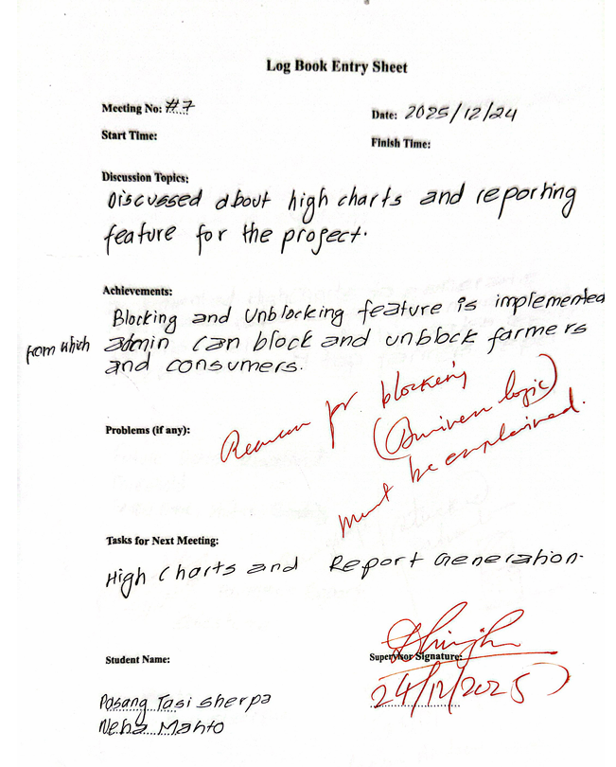

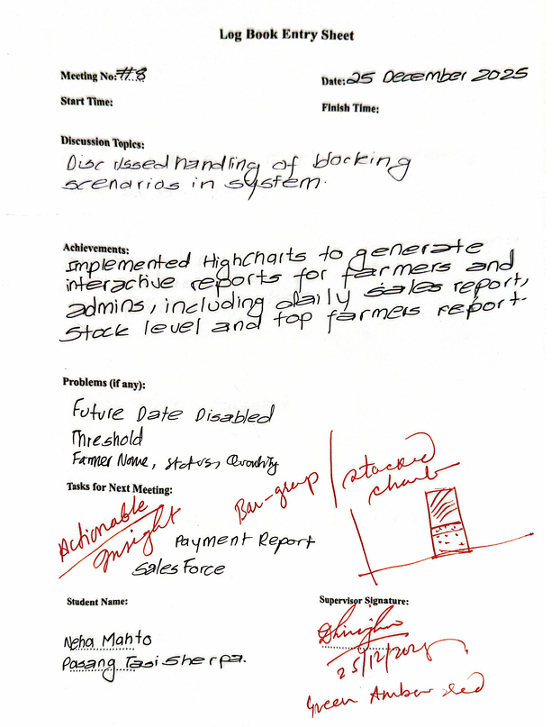

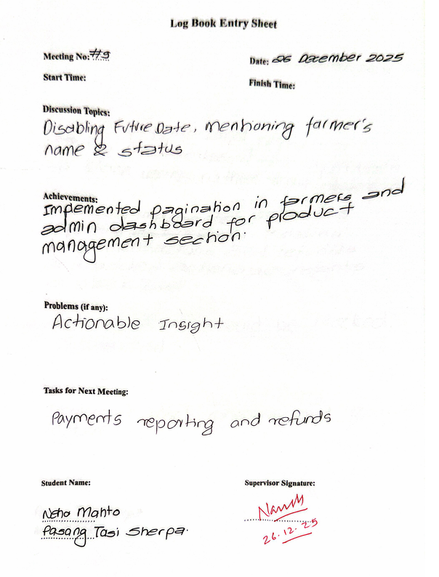

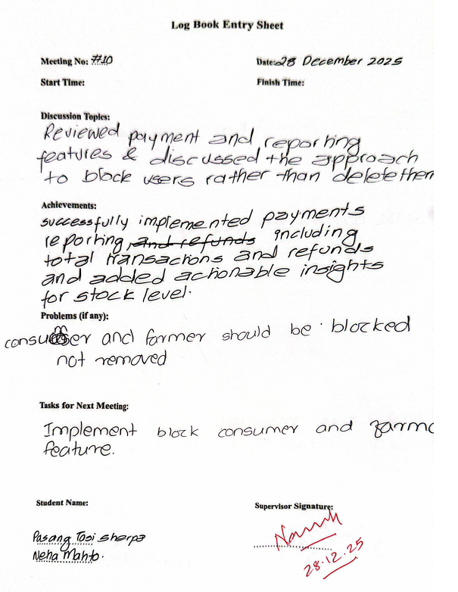

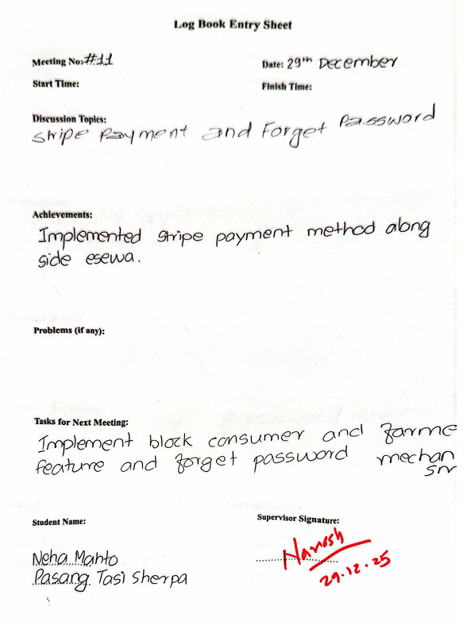

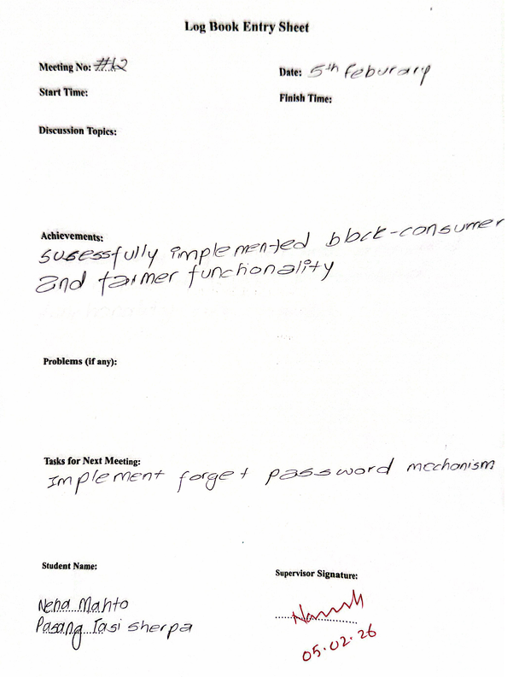

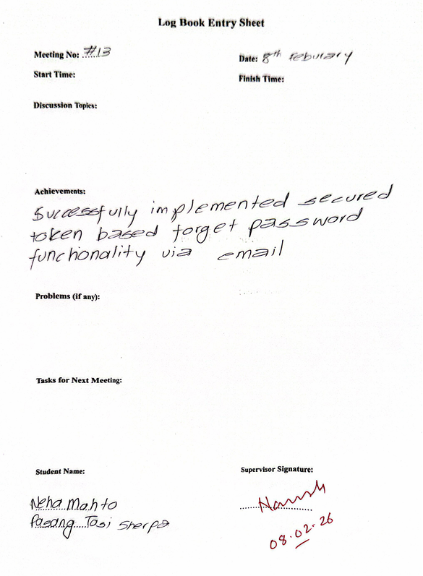



References
[1] R. P. King, G. DiGiacomo and R. P. Lev, “Direct marketing of farm products: Opportunities and challenges,” University of Minnesota, Dept. of Applied Economics, 2000.
[2] D. J. Pesch and T. L. Pesch, Direct Marketing of Agricultural Products. New York: Food Products Press, 1992.
[3] S. KC, “A study of agriculture based e-commerce portal,” Int. J. Environ. Agric. Biotech., vol. 3, no. 1, pp. 213-216, 2018.
[4] K. R. Neupane and G. B. Thapa, “Impact of market intermediaries on mandarin marketing: ‘Parasites’ or ‘Providers’,” Agric. Syst., vol. 84, no. 1, pp. 1-22, Apr. 2005.
[5] S. R. Lalonde and R. P. Singh, “Consumer supply chain demands and challenges at the farm–retail interface,” Brit. Food J., vol. 120, no. 8, pp. 1720-1734, 2018.
[6] A. Gurjar, A. Paliwal, D. Arse and A. Upadhayay, “Eatfresh: Direct Farm-To-Door Convenience,” Int. J. Multidisciplinary Res. (IJFMR), vol. 6, no. 6, Nov.-Dec. 2024.

